|  |  |  |  |  |
| --- | --- | --- | --- | --- |
| Table S1. Microsatellite loci genotyped and their corresponding primer specifications. | | | | |
| Primer ID | Sequence (5’-3’) | Repeat | Annealing temperature | Observed Allele Size range |
| KleSSR16 | F- GTGGATCGGACGGGATTTCT | (TTA)22 | 61.2 | 147 to 246 |
| R- GTTAGGTGGGCTTGGTAGGG |
| KleSSR18 | F- CATGGGATGCGATGGGATGG | (GAT)9 | 63.1 | 188 to 112 |
| R- CCCAGGCAGACAGCTGTATT |
| KleSSR23 | F- AATCCCTGCGGCGAAGAATT | (CTC)10 | 66.4 | 182 to 200 |
| R- CCGGAATCTGGACCAGTGAC |
| KLeSSR30 | F- GTACTCCGTTCCATGGGCC | (CTC)10 | 66.4 | 184 to 220 |
| R - TCTCCTCGTCCTCAATTGCG |
| KleSSR03 | F - TGGTACCATGCTGTTCACCA | (AT)15 | 60.9 | 175 to 199 |
| R- TGTTCATGAATAGTCCGGCC |
| KleSSR13 | F- TTGGCATCCGTCCATCACTC | (TTA)20 | 59.6 | 162 to 248 |
| R- GCCCAGTGGTTTTAGTCGGT |
| KlEST24 | F- GCCCAAAGTGATGCCATGAA | (CTC)7 | 62.7 | 211 to 220 |
| R- CTCTTCTTTGATGACGGCGG |

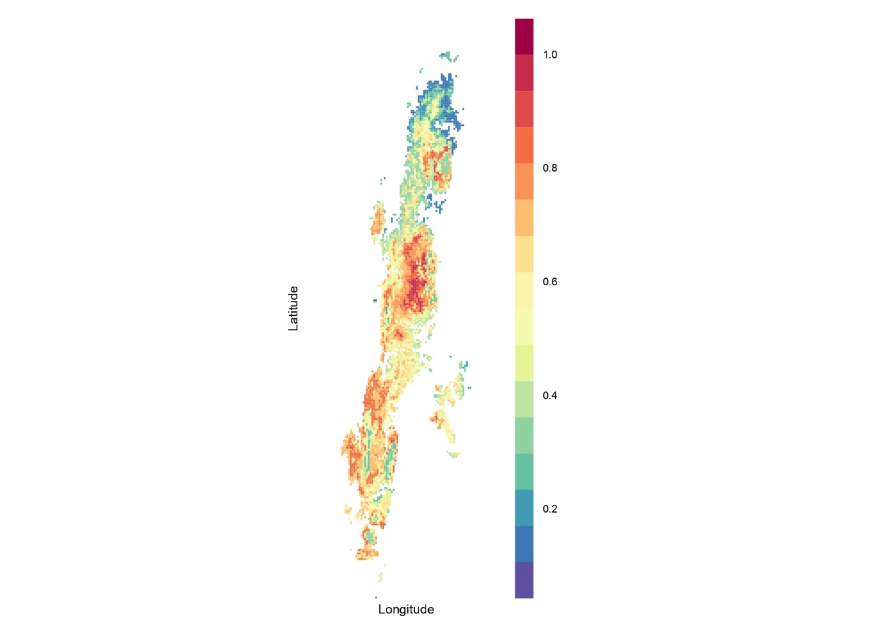

Figure S1 Predicted Ecological Niche of *K. rogersii* using MAXENT Niche modelling, AUC value <0.6

|  |  |  |  |  |
| --- | --- | --- | --- | --- |
| Table S2a HWE globally (across all 98 individuals) | | | | |
|  | chi^2 | df | Pr(chi^2>) | Pr.exact |
| Kle16 | 252.247 | 276 | 0.844 | 0.545 |
| Kle18 | 21.266 | 21 | 0.443 | 0.027 |
| Kle30 | 277.019 | 78 | 0 | 0 |
| Kle3 | 84.879 | 45 | 0 | 0.001 |
| Kle13 | 349.121 | 190 | 0 | 0.159 |
| Klest24 | 49 | 6 | 0 | 0.007 |

|  |  |  |
| --- | --- | --- |
| Table S2b Proportion of loci out of HWE across populations | | |
|  | Chisq | MC |
| Kle16 | 0 | 0 |
| Kle18 | 0.142857 | 0.142857 |
| Kle30 | 0.428571 | 0.285714 |
| Kle3 | 0.428571 | 0.142857 |
| Kle13 | 0.142857 | 0 |
| Klest24 | 0.142857 | 0.142857 |

|  |  |  |
| --- | --- | --- |
| Table S2Proportion of populations out of HWE | | |
|  | Chisq | MC |
| Interview_island | 0.333333 | 0.166667 |
| Radhanagar | 0 | 0 |
| Betapur | 0.166667 | 0 |
| Bakultala | 0.166667 | 0.166667 |
| Baratang | 0.166667 | 0.166667 |
| Havelock | 0.333333 | 0.166667 |
| ChidiyaTapu | 0.333333 | 0.166667 |

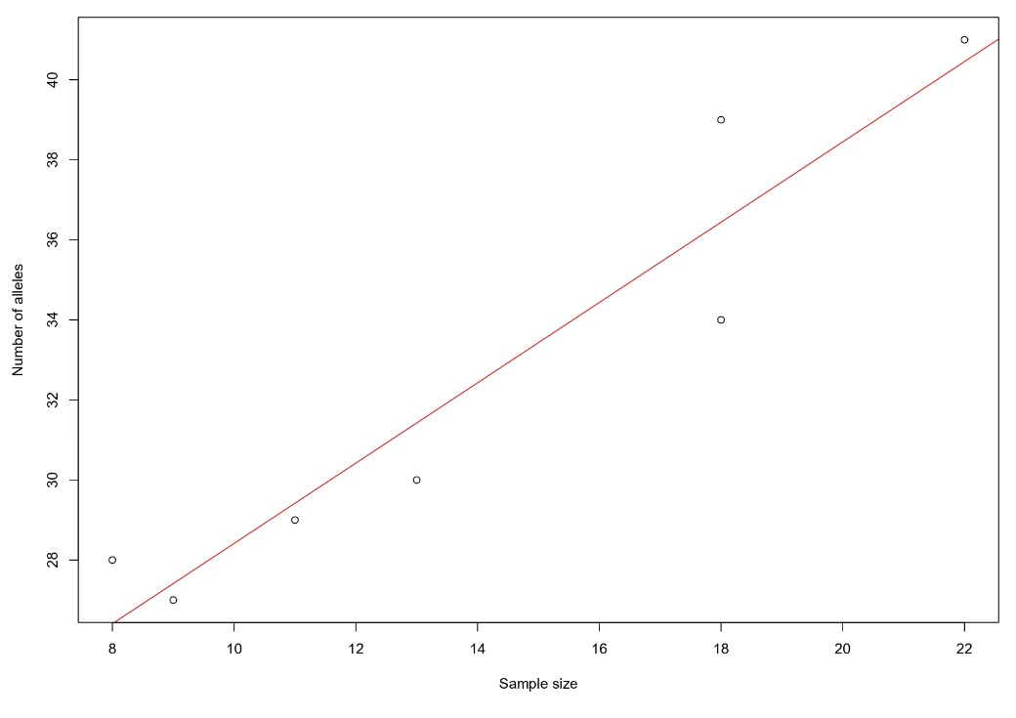

Figure S2. Number of observed alleles against population/sample size

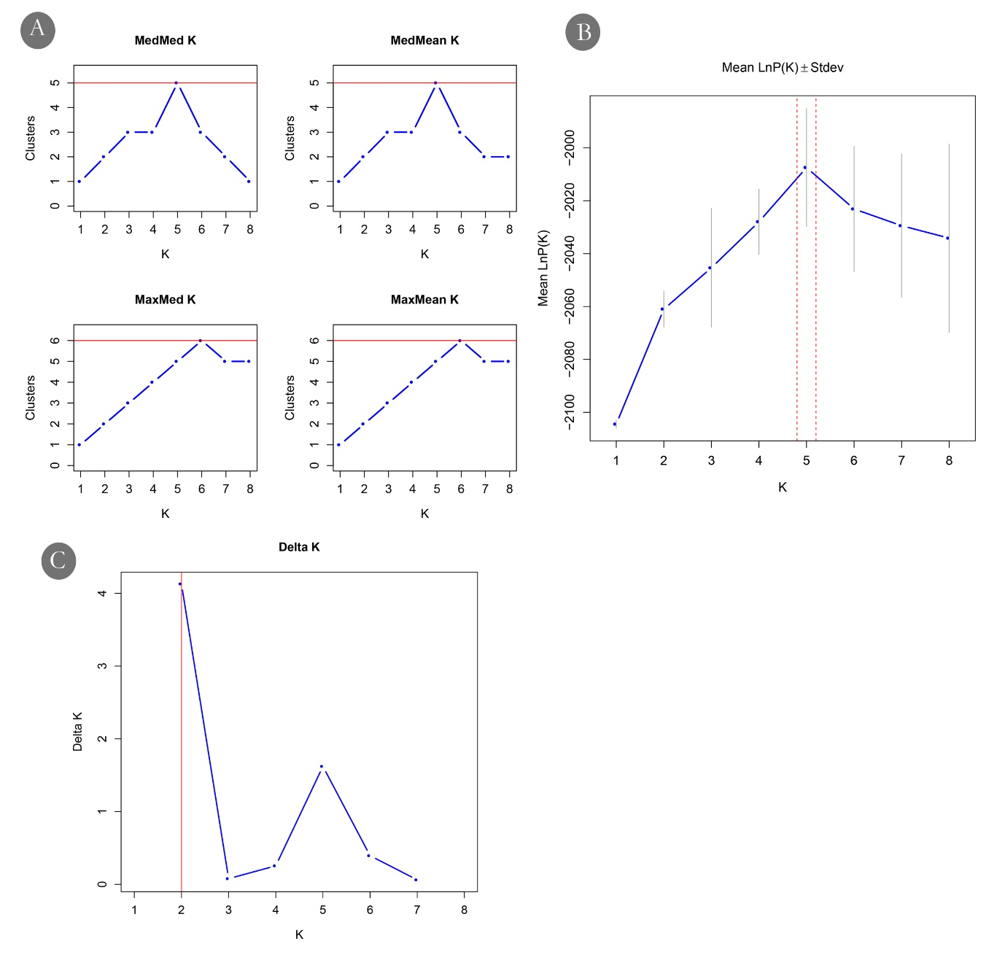

Figure S3. Best K evaluated using (A) medmedk, medmeak, maxmedk and maxmeak, (B) Ln Pr(X|K) and (C) ΔK statistics

|  |  |  |  |  |  |  |  |
| --- | --- | --- | --- | --- | --- | --- | --- |
| Table S3 bottleneck analysis | | | | | | | |
| Population | mean_N | mean_k | mean_He | p_W_1t_TPM | p_W_2t_TPM | p_W_1t_SMM | p_W_2t_SMM |
| Radhanagar | 15.43 | 4.43 | 0.6178 | 0.9727 | 0.0781 | 0.9805 | 0.0547 |
| Interview_island | 34.29 | 6 | 0.6593 | 0.9805 | 0.0547 | 0.9805 | 0.0547 |
| Betapur | 20.57 | 4.57 | 0.6243 | 0.5938 | 0.9375 | 0.5938 | 0.9375 |
| Bakultala | 26.86 | 4.57 | 0.5780 | 0.7656 | 0.5781 | 0.7656 | 0.5781 |
| Baratang | 24 | 4.71 | 0.6304 | 0.6563 | 0.8125 | 0.7656 | 0.5781 |
| Havelock | 34.71 | 5.29 | 0.6257 | 0.9609 | 0.1094 | 0.9609 | 0.1094 |
| ChidiyaTapu | 47.57 | 7 | 0.6514 | 0.9961 | 0.0156 | 1.0000 | 0.0078 |